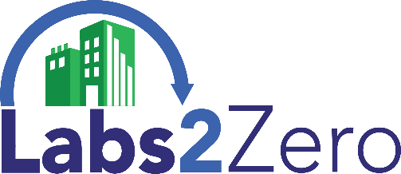
Labs2Zero Lab Consulting Partnership Agreement
This is a voluntary agreement between _________________________________ (“Consultant”) and the International Institute for Sustainable Laboratories (I2SL) to share data to help develop Labs2Zero tools in exchange for recognition. By signing this document, Labs2Zero Partners agree to have their organization and logo listed on the I2SL website and Labs2Zero Partnership materials.
As a Labs2Zero Consulting Partner, Consultant agrees to:
- Report energy, operational emissions, or embodied carbon related data and building characteristics that will all be anonymized by I2SL using the I2SL Laboratory Benchmarking Tool (LBT) on an annual basis from at least one lab facility where it is authorized to access the data, by February 28 each year.
- Allow I2SL website and materials to publish Consultant’s name and logo in conjunction with Labs2Zero Program Partnership.
Data collection deadlines will go into effect following the first six months after signature of this Labs2Zero Partnership Agreement and annually thereafter on February 28. Consultant will be informed they have six months after the deadline to retain Partnership status and use of the Labs2Zero Consulting Partner logo/Partner status, after which it will be suspended. Appeals may be made to the Labs2Zero Leadership Council regarding Labs2Zero Partner suspension.
To support the contribution of Labs2Zero Consulting Partners, I2SL will provide the following:
- Anonymity of any energy, emissions, or building data provided by Consultant to the LBT so that it cannot be recognized as being associated with the owner or its lab(s).
- International recognition of Consultant as a Labs2Zero Consulting Partner through events and outreach, including I2SL marketing materials, websites, signage, and correspondence.
- Access to a Labs2Zero Consulting Partner logo for use on Consultant’s website and marketing materials in accordance with the Labs2Zero Partner Mark Guidelines, provided Consultant maintains Partner status by meeting the above requirements.
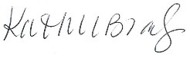
- Participation in Labs2Zero Partner Program events and potential recognition, award, or challenge programs designed to encourage and promote Labs2Zero Partners.
Signed on Behalf of I2SL: Kathleen Brady, Executive Director
Authorized Representative: (with authority to commit Consultant to share clients’ data)
Signature: _______________________________________________ Date: ________________
Labs2Zero Partnership Contact:
Name: _____________________________________ Title: ___________________________________
Address: ___________________________________ City/State/ZIP: ___________________________
E-mail: _____________________________________ Number of lab buildings in portfolio: ______

